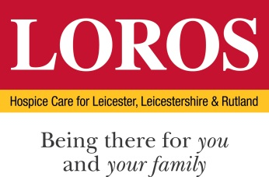

PERSON SPECIFICATION

POST: Café Assistant

DEPARTMENT: Catering

 | Essential Criteria | Desirable Criteria | How & When
Education / Qualification | - GCSE grade C or above or equivalent  - Basic Food Hygiene | - Food Safety Level 2 | Certificates/  Application
Skills / Abilities | - Ability to stay calm under pressure  - Good communicator / Team Player  - Understanding of produce and ingredients  - Cash Handling  - Customer facing Service – retail or catering  - Flexible in your approach and have the ability to work on own initiative  - Good Oral and Written Skills | - Proven customer service skills  - Experience of basis food preparation  - Stock Control | Application  Interview/ Assessment Centre  References
Experience | - Be able to demonstrate experience in a customer facing environment  - Experience in a café/coffee shop setting or Retail | - Barista trained | Application  Interview/ Assessment Centre  References
Knowledge | - Good food knowledge | - Dietary and Allergen awareness  - COSHH awareness and understanding | Interview/ Assessment Centre
Motivation and personal attributes | - Able to contribute to LOROS’ Values & Behaviours  - Bags of personality and a fantastic work ethic are essential  - A warm personality with a happy, welcoming approach to customer service both with internal and external customers  - Strong work ethic  - Team minded  - Solution focused  - Organised |  | Interview/ Assessment Centre

