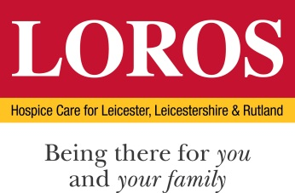

PERSON SPECIFICATION

POST: Abbey Park Café Manager

DEPARTMENT: Catering

 | Essential Criteria | Desirable Criteria | How & When
Education / Qualification | - Minimum NVQ Level 1 in hospitality & catering and/or professional cookery OR proven experience of working in a similar role  - GCSE grade C or above or equivalent  - Health and Safety and L2 Food Hygiene or Equivalent  - HACCP Training | - Level 2/3 NVQ in Hospitality & Catering  - Train the Trainer  - Aspiring leadership training  - Customer service training  - L3 Food Hygiene | Certificates/  Application
Skills / Abilities | - Ability to inspire your team to deliver best service possible  - Good communicator and lead by example.  - Team player and Role Model.  - Quality Food Production  - Understanding of produce and ingredients  - Stock Control  - Cash Handling  - Flexible in your approach and have the ability to work on own initiative  - Rota and food cost budgeting to keep in line with allocated budget  - Good Oral and Written Skills  - IT Skills Excel/Word/E Mail | - Ability to write menus that are both creative and profitable  - Ability to cost a menu and produce selling prices in line with the GP target | Application  Interview/ Assessment Centre  References
Experience | - Managing Staff of 5 people or more.  - Good food knowledge – including sales performance and food wastage controls.  - Barista trained  - Be able to demonstrate experience in a food retail environment.  - Previous Manager or Deputy within Catering environment. | - Experience within a high street coffee outlet advantageous.  - Fast paced environment | Application  Interview/ Assessment Centre  References
Knowledge | - Dietary and Allergen awareness  - COSHH awareness and understanding  - HACCP  - EHO visit management  - Food budgeting per portion and food wastage  - Stock ordering in line with budgets. |  | Interview/ Assessment Centre
Motivation and personal attributes | - Able to contribute to LOROS’ Values & Behaviours  - Passion for cooking  - Bags of personality and a fantastic work ethic are essential  - A warm personality with a happy, welcoming approach to customer service both with internal and external customers  - Strong work ethic  - Driven by ownership or department  - Team developer / Succession planning  - Solution focused  - Organised |  | Interview/ Assessment Centre

